The Solidisk TWOMEG 128K Memory Expansion

Contents:
---------

- Installation.
- The MENU program.
- The MANAGER program.
- The PRINTER program.
- Other programs.

(c) 1987 Solidisk Technology Ltd. All rights are reserved.
Neither the whole nor any part of the information contained in, or the products described in, this manual may be adapted or reproduced in any material form except with the prior written permission of the Copyright holder. The products described in this manual are subject to continuous developments and improvements. All information is given in good faith. However, Solidisk Ltd shall not be liable for any loss or damage arising from the use of this information or products described in this manual.

Technical help line: Southend (0702) 43 11 22
Solidisk Technology Ltd, 17 Sweyne Avenue Southend on Sea Essex

I— Installation:
----------------
Proceed as follows:
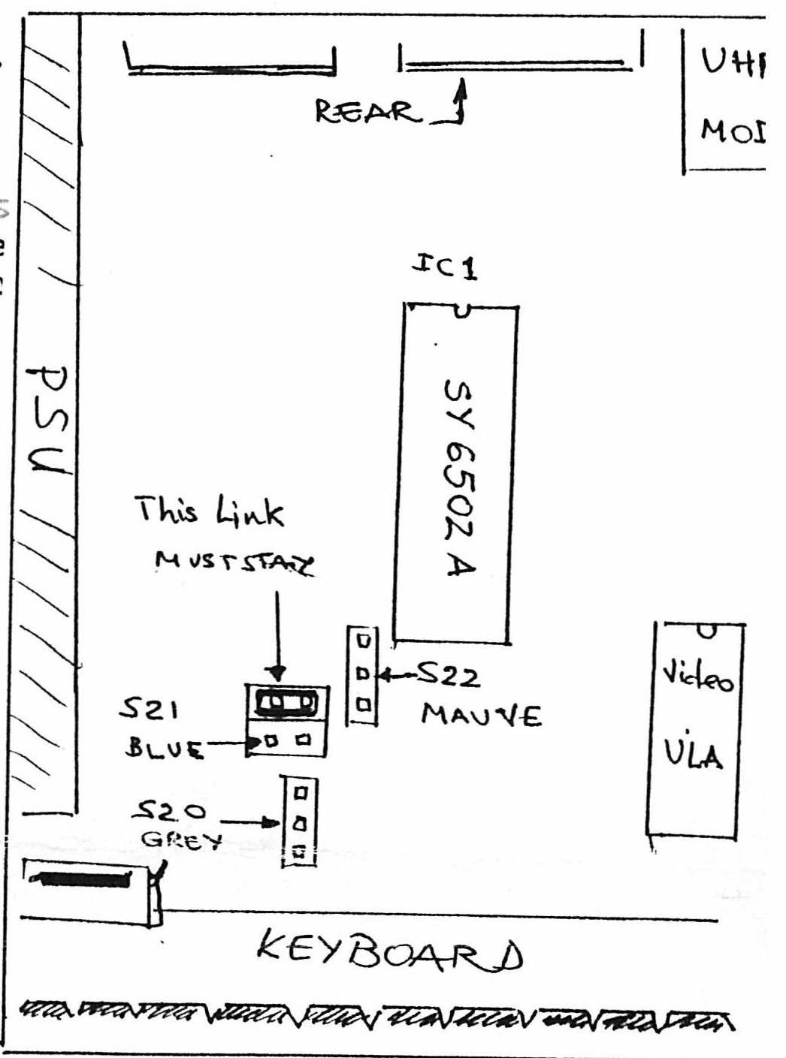
a) Open the computer case.
b) Remove the 3 links S20, S21 and S22.
c) Remove the 6502 CPU (IC1).
d) Fit the 6502 CPU onto the TWOMEG128 board.
e) Place the two blue socket spacers either into the CPU socket on the BBC board or under the expansion board.
f) Install the expansion onto the socket on the BBC board.
g) Connect the three colour wires: blue to S21, mauve to S22 and grey to S20.
Disconnect the computer from the mains. Open the computer by undoing 4 screws labelled ‘FIX’, using a Stanley Posidriv No 1. The 3 links or metal covered by plastic short—bars (coloured blue or black) are located towards the centre of the computer board. S21 has actually 2 links, the right one is toward the keyboard. Remove them (3). If you switch on the computer at this stage, you should see the message:
BBC Computer 32K
Language?
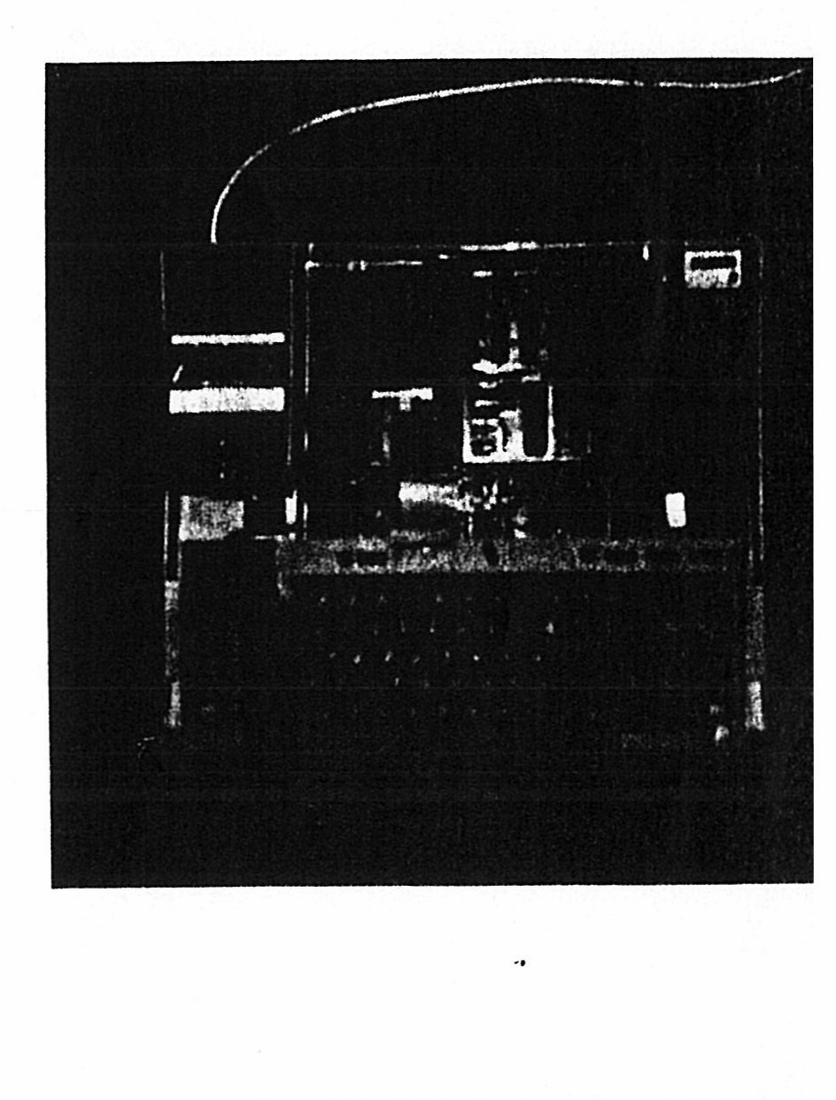
This means that all the ‘Sideways Roms’ are not seen by the computer as their control passes through the links you removed. The 6502 CPU is the large 40-pin IC lying just above the 3 links. Remove it using a medium sized, flat blade screw driver (or a knife). Introduce the blade under the IC and twist it left and right to prise the IC out. You will have to decide in the next step which way to fit the blue spacer. This is a stack of two special blue 40-pin IC sockets. You can fit it either onto the now empty CPU socket on the BBC computer or under the same existing spacer on the expansion. Which ever way, the result is the same: a 3 blue socket stack will support the expansion on the BBC board. Line the expansion on top of the CPU socket and

press down. Install the CPU chip back into the empty 40-pin socket on the expansion, the notch on the IC facing the same way as it was in the BBC computer board, ie to the rear of the computer. Inserting the CPU in the wrong way will, lock the machine up but will not damage the IC for a short while. Push the coloured wires one by one to the metal posts where the links were removed. The blue wire to S21, power supply side (left), the mauve wire to S22, middle post, the grey wire to S20, same to the middle post. The blue wire controls the chip select (CS) of the 4 Sideways ROM sockets on the BBC board, the other two wires select one of the four ROM sockets when the blue wire (S21) is active. S20 (grey) is the high bit selecting either the two right sockets when held high (or left open), S22 (mauve) the low bit, selecting on of the two sockets of either the left pair or the right pair sockets.
The installation is now complete. Switch on the computer and it should display exactly the same message as usual. If it does not, you may find the fix in one of the following cases:
1— No screen and just a buzz in the loudspeaker: one of the pins of the stack is either not connected to the expansion or to the BBC computer. Another possible cause is that the mauve or the grey wire could be in the wrong place. The CPU could be (although rarely) in the wrong way. Remove the expansion, examine the connection and refit.
2— Screen shows ‘Language?’. One of the coloured wires has either broken off from the expansion or is connected to the wrong place. Check, resolder if necessary and refit.
3— Some of the usual ROM titles are missing on the screen. The grey and blue wires may be in the wrong way round or one of them is either broken off at the expansion side or connected too loosely to the metal posts. Check and squeeze the metal tags a little with either finger nails or a small pair of pliers to make them tighter if necessary.
4— Blank screen with only a cursor on the top left corner. The keyboard tail may have been disturbed. Push it back in place.
5— Keyboard inoperative. Undo and refit the expansion.
In any case, if you suspect that the computer is not working as usual, please give us a ring on our direct Technical Help Lines:
Southend (0702) 43 11 22
As it is, the expansion will give you 4 extra ROM sockets, numbered 8, 9 10 and 11 from left (lower priority) to right. They are more accessible than the ROM sockets on the computer board and have priority over the latter. Some software in ROM from Computer Concepts will also detect immediately the presence of the shadow RAM, such as Wordwise Plus (version 1.4F), Interword, Inter Sheet (most recent) and Spell Master. We have not yet tested with InterBase but suspect that also will work.
The relevant software will have to be loaded to use the other features of the board and that is exactly what we shall talk about now.

II— The MENU program (version 1.2):
-----------------------------------
If you have Solidisk 2.2 or 2.1 DFS, you can load ROM images
directly from floppy discs to any RAM bank.
- In DFS: *LOAD <ROM image name> <bank,8000>
- In ADFS: *LOAD <path,ROM image name> <bank,8000>
Example: *LOAD SOLIMON 48000 wi11 load Solimon into bank 4.
*LOAD :l.ROMS.MANAGER C8000 will load Manager from drive 1 into
bank ‘C‘.
Alternatively, use the MENU program.
The MENU is on software disc Nol, in DFS format. Select DFS if you have Solidisk 2.1 ROM and boot up the disc by <Shift> <Break>. The screen will show the main resources of your computer: ROMs, RAMs and programs on disc No 1.
On the top part, you will find 16 boxes representing all the possible 16 ROM sockets on the computer. If the socket is occupied by a ROM, its title is then shown in the relevant box. If the socket is a RAM, it will be shown as a ‘+‘ sign. If it is vacant, the box is blank. Each box has a number, from 0 to 9 then A, B, C, D, E and F (or 10 to 15 in hex).
Boxes 4, 5, 6, 7, C, D, E and F are normally shown as RAMs. You can load ROM images into them and presto, they will behave identically as their ROM counterparts.
There are a few ROM images you can load from the same disc:
MANAGER, PRINTER, SOLIMON, SI.MAIL, UVPR32 and UVIPROM.
a) Select a RAM box:
--------------------
Use the ‘>‘ key (Shift’.’) to move to the next (higher) RAM box or the ‘<‘ key (Shift ‘,‘) to move it to a lower RAM box.
b) Select a ROM image:
----------------------
There is no way to tell a ROM image file from any other file from the display. You know because you have made them yourself or because you have been told. On the disc, MANAGER, PRINTER, SOLIMON, SI.MAIL, STLOEOO, UVPR32 and UVIPROM are ROM images from Solidisk. To load a ROM image, press the letter shown in front of the name. So, if after selecting box ‘C‘ and you press the letter ‘K‘ (presumably that is what is shown) as in front of the name ‘Manager’, you should hear the disc going for a couple of seconds and the ‘+‘ in box C’ is now replaced by ‘MANAGER‘. You have just loaded the Manager ROM image. It will behave exactly as if it were supplied in ROM (which would cost you £3 + p&p). The next RAM box will be automatically selected to reduce your work to a minimum. If for example you want to load all the ROM images on the disc to your TWOMEG 128K expansion, you only have to press one by one F, G, H, I, J, K.
To exit from the MENU and initialise all your ROM images, press
<BREAK>.

c) To select a program:
-----------------------
To select a program as shown on the display, press the corresponding letter shown in front.
d) To write—protect ROM images:
-------------------------------
Some ROM images are normally not meant to be used in RAM form. You may be able to use them still providing you write-protect them first. Load the image(s) as usual the press the ‘*’ (asterisk) key. Close the write-protect switch if it has been installed, then press <RETURN>. The MENU program will store 0 127 into location &FE4E, forcing the computer to cold-start thus getting round some of the obstacles.
e) To save a RUM image:
-----------------------
Press the ‘@‘ key then enter the box number where you see the ROM appearing. Eg @1 may save your STL DDFS 2.2 on disc. Once saved, the ROM images can be loaded as all the other images on the disc.
f) To change Disc:
------------------
Press the ‘?’ key to inform the MENU that you have changed your disc.
g) To exit from MENU:
---------------------
Exit by running another program (press the corresponding key) or by pressing ESCAPE key or the * key or the BREAK key.

III - The MANAGER program:
--------------------------
This program is a ROM image which can be bought optionally for £3+p&p. It has three basic functions:
— To control the Shadow RAM.
- To control the RAM disk.
— To control the printer buffer.
There are several versions of the Manager, each optimised for a memory usage. The present Manager should be loaded in bank ‘C’ or ‘E’, the unused memory portion of this model. This version will offer 64K RAM disk (using bank 4, 5, 6 and 7), 24K printer buffer even when the RAM is write-protected (using Shadow 2), a 20K Shadow RAM for all screen modes and a small sideways RAM bank 8K for small ROM images (Solimon, Uviprom etc). The total storage capacity for this model is 64K+24K+20K+8K=116K out of

128K available. The Manager will sign up with its slot number eg
‘MANAGER 128-C’ if loaded in ‘C’.
1) Shadow RAM:
--------------
The Shadow RAM is a block of paged memory, sharing the same space as the screen memory. The control software will select which page (ie shadow or screen) should be accessed at any time. If the screen is selected, the shadow RAM is off, otherwise, the shadow RAM is on. Either way, the contents of both pages are preserved as long as the computer remains switched on. Some software prefers to drive the shadow system itself, most of Computer Concepts recent packages do (Inter—series and Wordwise Plus l.4F). The majority don’t and leave the control of the Shadow RAM to the Manager (the View 3.1 family, Basic, Pascal, Solimon, UVIPROM etc). It is therefore convenient to have the Manager in ROM.
a) Nothing to do:
-----------------
If you use self—driving software, there is more nothing to do. The software merely recognise the added memory and use it. For example, you will get 27,922 bytes free with Interword in any screen mode.
b) Enter *SHADOW:
-----------------
Basic, Pascal, Solimon, ADE etc require the Manager to be present or loaded and initialised (in ‘C’ or ‘E’, the unused portion of this model). Enter *SHADOW <RETURN> followed by a screen mode change or press <BREAK>. The Manager will show its shadow status by ‘Shadow 0’ on the top of the screen.
c) Enter *PLUS:
---------------
View 3.1, Wordwise l.4C and l.4E will require *PLUS, the swap RAM (or toggle) mode. This has to be done only once (or repeated after hard break).
d) Enter *SHADOW OFF:
---------------------
This command is seldomly used. It has the effect of restoring the computer to the normal power—up state and has no effect on self—driving software.
e) Advanced *FX calls:
----------------------
Several FX calls and oswords are implemented to support Master type software. FX 68, 69, 108, 114 are implemented and also oswords 66 and 67. If you need any technical specifications on these calls, please order the book ‘Master Reference 2’ (Acorn). We may at a later date implement all *SR functions. The Shadow RAM may be accessed directly in machine code (or small Basic programs). It is mapped from location &2000 to &7FFF. Store &80 into the shadow latch (&FE34) will select the shadow, 0 will

deselect it. The Manager keep a copy of the latch at location &DFO+X (ROM private byte) - X being the ROM slot. It is more prudent to use *FXl08 1 to set shadow and *FX 108 0 to unset. The mechanism above allows direct access to the screen and private RAM (&2000 to &3000).
2) The Printer Buffer:
----------------------
The Printer buffer is 24K bytes long and unaffected by BREAK or ESCAPE keys. Pressing BREAK will halt printing while •ESCAPE will prevent new bytes to enter the buffer.
a) *PRINTER:
------------
Enter *PRINTER <RETURN> to set the printer buffer up. If The Manager ROM is in a higher priority slot than the Disc Filing system, it will sign up with ‘(P)’ when active,
eg ‘MANAGER 128-C (P)’.
PRINT ADVAL -4 will show 24,576 bytes free (normally 63).
b) *PRINTOFF:
-------------
This command restores the normal printer buffer (63 bytes) and will flush (cancel) the previous buffer.
c)*STREAM <0—7>:
----------------
This command can allow fast ‘lift and put down’ work in place of
*SPOOL. The printer must be switched off, enter *PRINTER.
- To ‘lift’, output to the printer what you want eq list lines
10, 1000 after VDU 2 or Control-B or choose the PRINT option
from your wordprocessor, spreadsheet, database etc.
- Switch the context, eg load the program where the lifted lines
will be merged or a new document etc.
- To ‘put down’, enter *STREAM 0. This will remove bytes from
the buffer and insert them into the keyboard. Other STREAM
commands:
*STREAM 1 : out to RS 423 input buffer.
*STREAM 2 : out to RS 423 output buffer.
*STREAM 3 : out to the printer (normal *printer).
*STREAM 4 : out to the Sound Channel 0.
*STREAM 5 : out to the Sound Channel 1.
*STREAM 6 : out to the Sound Channel 2.
*STREAM 7 : out to the Sound Channel 3.
The *PRINTER has it ‘glue’ code stored in the normal printer buffer (location &0880 to &O8BF). If any stream is being used, the printer must be switched off.
3) The RAMDISK:
---------------
The RAM disk is 64K in size (&1000 in hex) and occupies normally 4 banks of Sideways RAM from 4 to 7 which emulate the Master. It is no chance that the Manager (and all other program on this

discs) will work on the Master 128K or the Compact. The RAM disk can be made in two formats: DFS and ADFS depending on which ROM in the system you have.
— With Solidisk 2.2 ROM: DFS format.
— With Solidisk 2.1 ROMs: either DFS or ADFS.
*RAMDISK (*RA. <0—3>):
----------------------
This command creates the Ramdisk or changes the drive number associated with the Ram disk. Eg *RA.1 will make (or change to) the Ram disk as drive 1. The format is implied by the Disc Filing system in use so there is no need for further specification. The size is fixed to 64K. Likewise, *RA.0 will make drive 0 appear in RAM.
Once created, any reference to the drive assigned to the RAM disk will be serviced by the Manager, ie no noise, wear and tear and at an incredible speed. Any program no matter how long it is, can be loaded quicker than you can remove your finger. You can DZAP the RAM disk exactly as if it were a floppy. In general, its behaviour is very much like a Winchester drive but with no spin-up time and no noise (and even faster).
b) Normal steps:
----------------
The normal set—up would be assigning first drive 3 to the RAM disk, copying whatever you want onto the RAMDISK by:
— in DFS: *COPY 0 3 * (or any other specification).
— in ADFS: *COPY * :3 (or any other specification).
Then change the drive number to a more convenient number. Eg *RA.0 or *RA.1
Some precautions should be taken when starting up the RAM disk by an EXEC file.
— The Manager if loaded will have to be initialised. You may load it into bank C and store 130 (hex &82) in location &2AD immediately after.
*RA.3 can then be inserted.
- Copy or backup files across to the RAM disk.
— If *RA.0 is required and the exec file is on drive 0, either
*backup should have been used to copy the files across in the previous step or this must be done in a program, otherwise, the Disc Filing System would take the next instruction from the wrong place eg from the Ram disk as opposed from the real floppy.
— Don’t copy too much across. The size of the RAM disk is limited to 64K. Other versions offer l00K with shadow or 124K without.
*RAMOFF:
--------
This command removes any drive number assigned to the RAM disk.

*RAMADFS:
---------
This command is only useful if you have Solidisk 2.1 ROM. It creates a Ramdisk in ADFS format while you are in DFS.
*RAMDFS:
--------
This command is only useful if you have Solidisk 2.1 ROM. It
creates a Ramdisk in DFS format while you are in ADFS.
4) *TESTRAM:
------------
This command performs a thorough RAM test and should show ‘128K bytes tested OK’.

III) The PRINTER program:
-------------------------
This program, more appropriately called a 15K printer buffer program, can be used in any bank from 4 to 7, from C to F. Its becomes useful when you use self driving software (see above) which does not let the Manager ROM have a copy of the shadow latch setting. A typical case would be with Interword and Spell—Master. The TWOMEG 128K is ideally suited for this combination. You may have a 64K RAM disk, shadow and printer buffer, all internally fitted. An owner of the Master may have only 32K of Sideways RAM for fitting Interword or Spellmaster internally or to put up with bare boards plugging into the cartridge slots.
Load PRINTER into any slot. Load the Manager only if you need
RAMDISK.
IV) Other programs:
-------------------
If you are interested in obtaining Manual(s) for any program in the software pack 1, please let us know. Anyone interested in using the board for assembling Sideways ROM code should buy the ‘Printer Source Code’ disc and listings which contain all the normal layout for a Sideways ROM (service entry, reserve vectors, command table, help, errors etc).
We hope that this manual, although intended to be brief, will help you to get the best out of the TWOMEG128K expansion.

(c) 1987 Solidisk Technology Limited. Revision 1 May 87.

